ECE 4655 Project 3, Canny Edge Detector

In project 3, we made a program to perform Canny edge detection on grayscale images. The basic algorithm for Canny edge detection is:

1. Create a low-pass filtered image
2. Find the gradients in x and y directions
3. Compute the magnitude and direction of the gradient
4. Find a thinned edge version of the magnitude
5. Perform hysteresis thresholding to get the final edges

For step one, I used a Gaussian kernel of varying size and sigma values. To compute the x and y gradients, the respective I used Sobel kernels. For computational efficiency, the gradient kernel can be convolved with the Gaussian kernel, and the result used on the image to get the gradient. I used a single pixel 0 pad on the Gaussian kernel for the convolution of the kernels. For convolution of the derivative of Gaussian with the main image, I used replication padding since zeros leave a hard edge around the border.

Step three was the simplest one in Matlab since it only required one line of linear algebra each for the magnitude and direction images. Using the x and y gradients as Fx and Fy, the magnitude could be computed by F = sqrt(Fx.^2 + Fy.^2), and the direction by

D = atan2(Fy,Fx) \* 180/pi for results in degrees.

Step four, non-maximum suppression, I looped through the direction matrix, used four values: 0, 45, 90, 135 degrees, to determine if the pixel was the local maximum along the gradient direction. If it was, the intermediate thinned-edge image pixel was set to the corresponding value in the magnitude image. If not, it was set to zero.

For the final step, I chose a high and low threshold based on the non-zero pixel values in the thinned-edge image. The median worked well for Fig1010, but for Fig1001, I had to choose the thresholds manually. Using those values, I created 2 new images. One with strong pixels, ones with values above the high threshold, and one with weak pixels, values between the high and low threshold. I added those together as an intermediate step and created a zeroed array to track which pixels were visited. Using a loop, I set the final output image pixels to 255 if the threshold pixel was strong, or if it was weak, but next to a strong pixel. Otherwise, the weak pixels were set to 0.

Of the two required images, I found that changing the filter size did not have much effect until it was very large. At which point, the final edges had some large discontinuities. But for filter size 3 and 11, the difference was negligible. For Fig 1016, changing the filter from 3 to 11 removed many of the details from the final result. The bricks in the image are close to 11 pixels in height, so it makes sense that they would be reduced or removed by a low-pass filter. Changing the Threshold also made a large difference in what details were removed in the final step. Using a median of the non-zero values as the low threshold as opposed to a flat 50 kept the roof lines in the final edges, and some edges from the brick.

Youtube Link: <https://youtu.be/h6wdBVBc3S8>

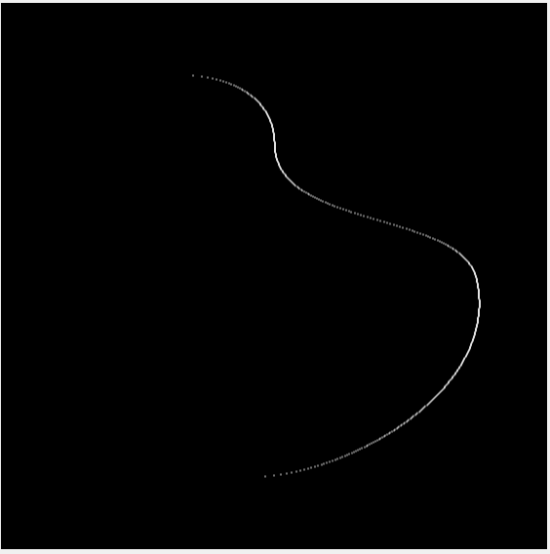Images:

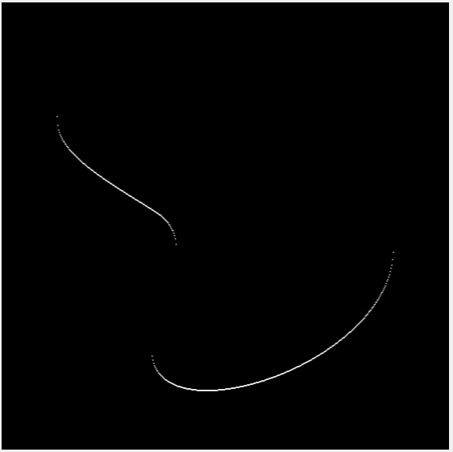

Figure 1001

x gradient

Filter Size 3x3

Fig 1001 Original

Figure 1001

y gradient

Filter Size 3x3

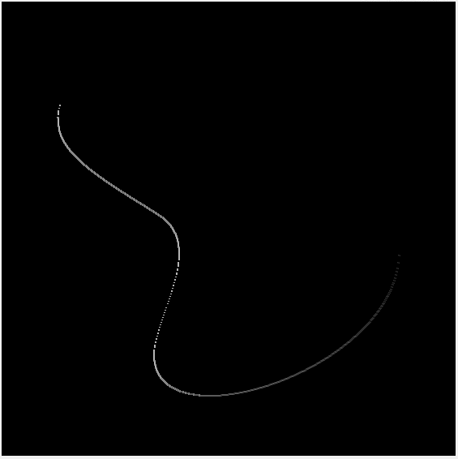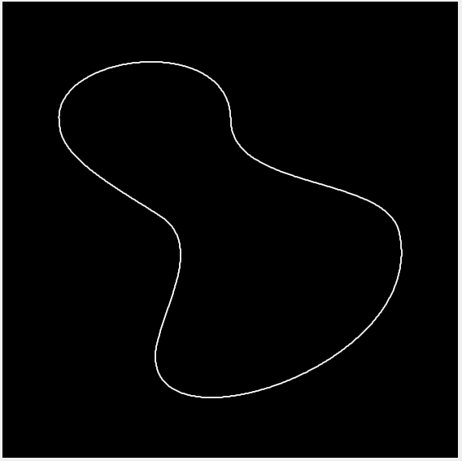Left: Figure 1001 Gradient Magnitude

Filter Size 3x3

Right: Figure 1001

Gradient Direction

Filter Size 3x3

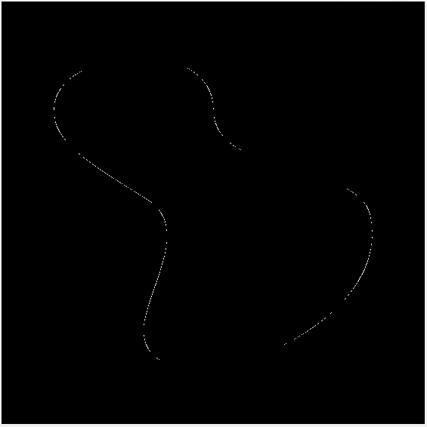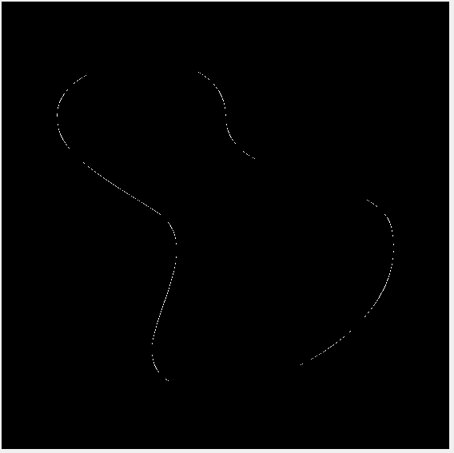

Left: Figure 1001

Non-Max Suppression

Filter Size 3x3

Thresholds:

High 100

Low 50

Right: Figure 1001

Final Result

Filter Size 3x3

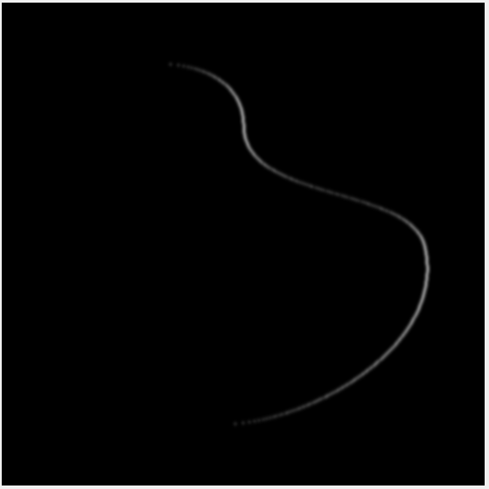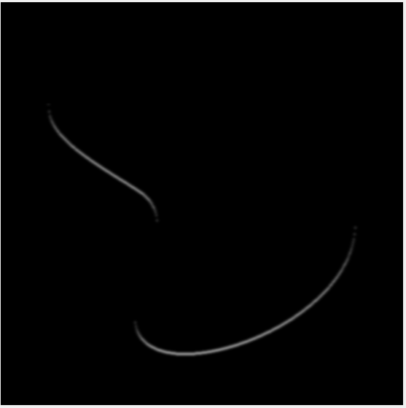

Left: Figure 1001

x gradient

Filter Size 11x11

Right: Figure 1001

y gradient

Filter Size 11x11

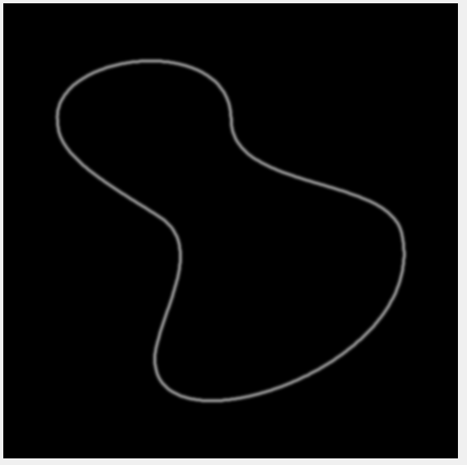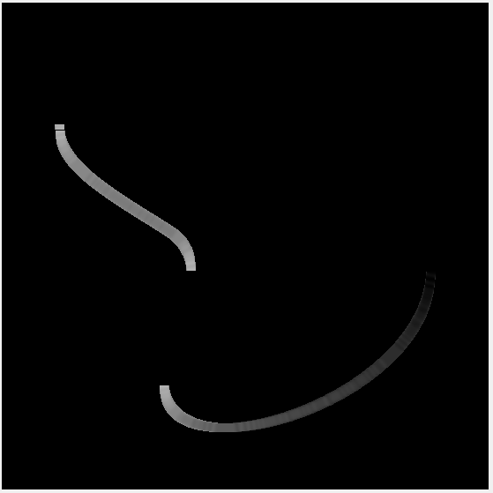

Left: Figure 1001

Gradient Magnitude

Filter Size 11x11

Right: Figure 1001

Gradient Direction

Filter Size 11x11

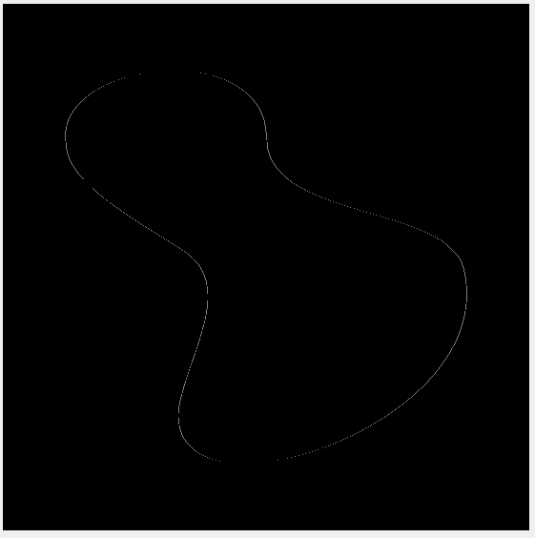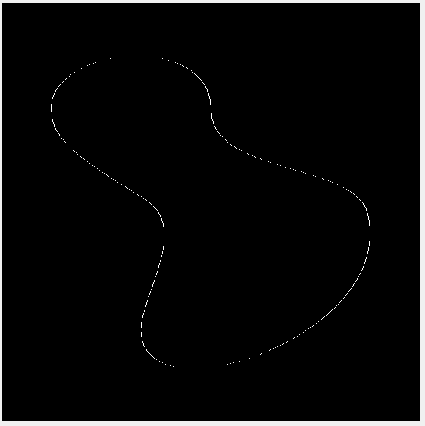Left: Figure 1001

Non-Max Suppression

Filter Size 11x11

Right: Figure 1001

Final Result

Filter Size 11x11

Figure 1016 Original

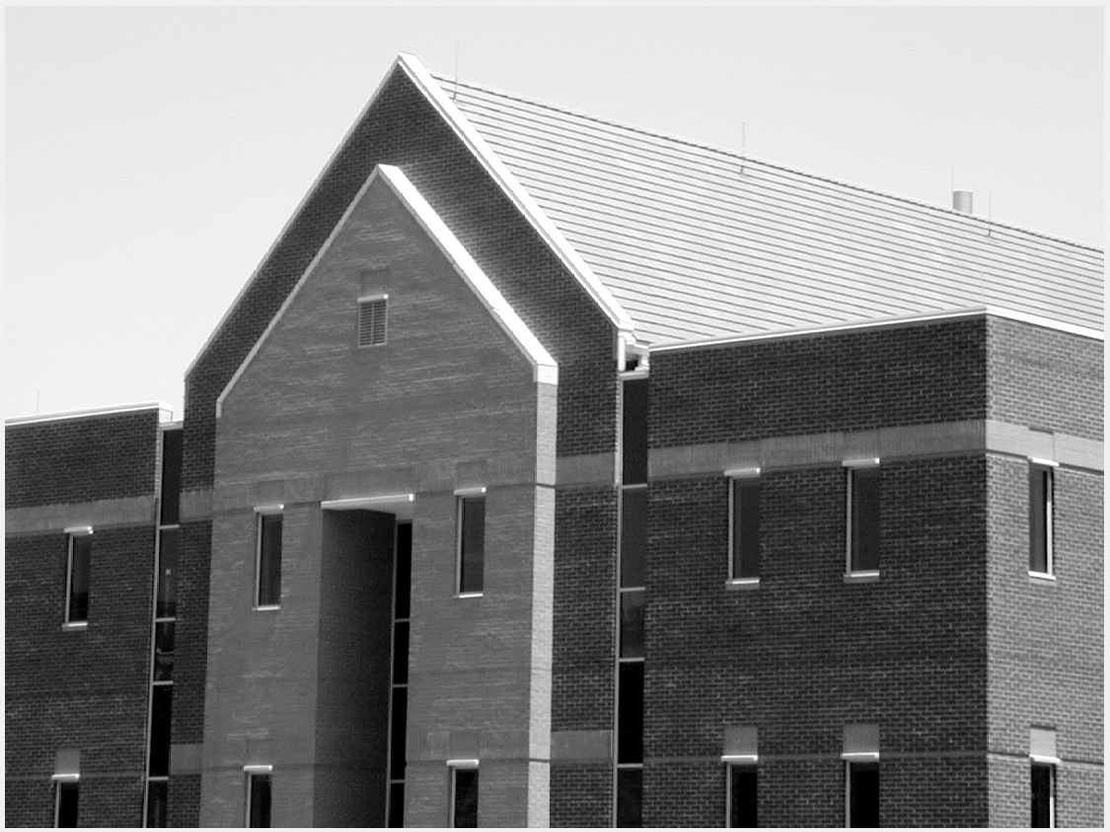

Fig. 1016 Fig. 1016

x gradient y gradient

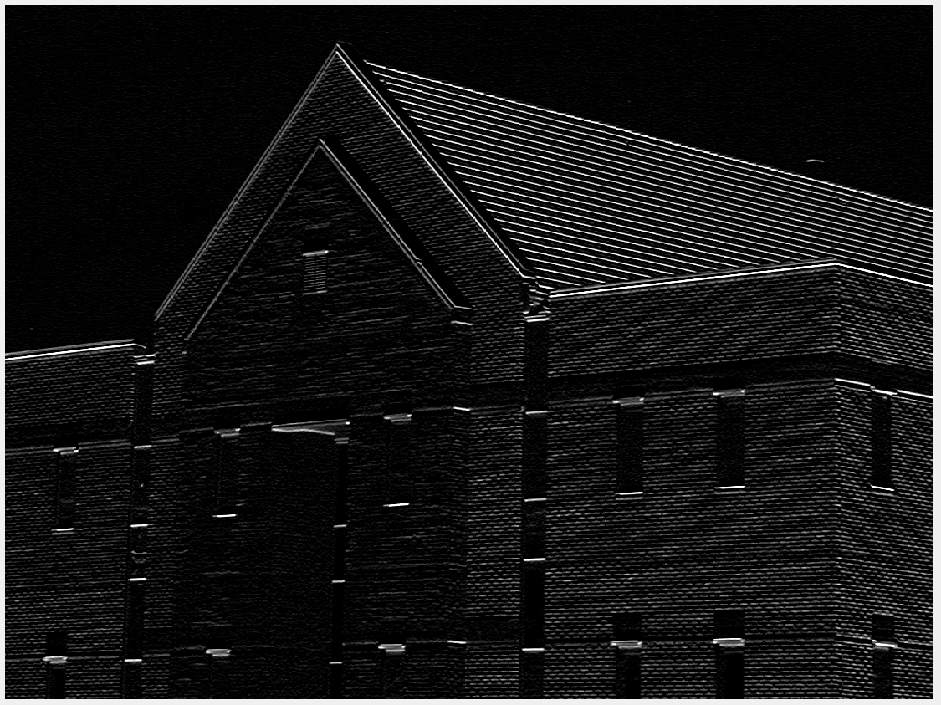Filter Size 3x3 Filter Size 3x3

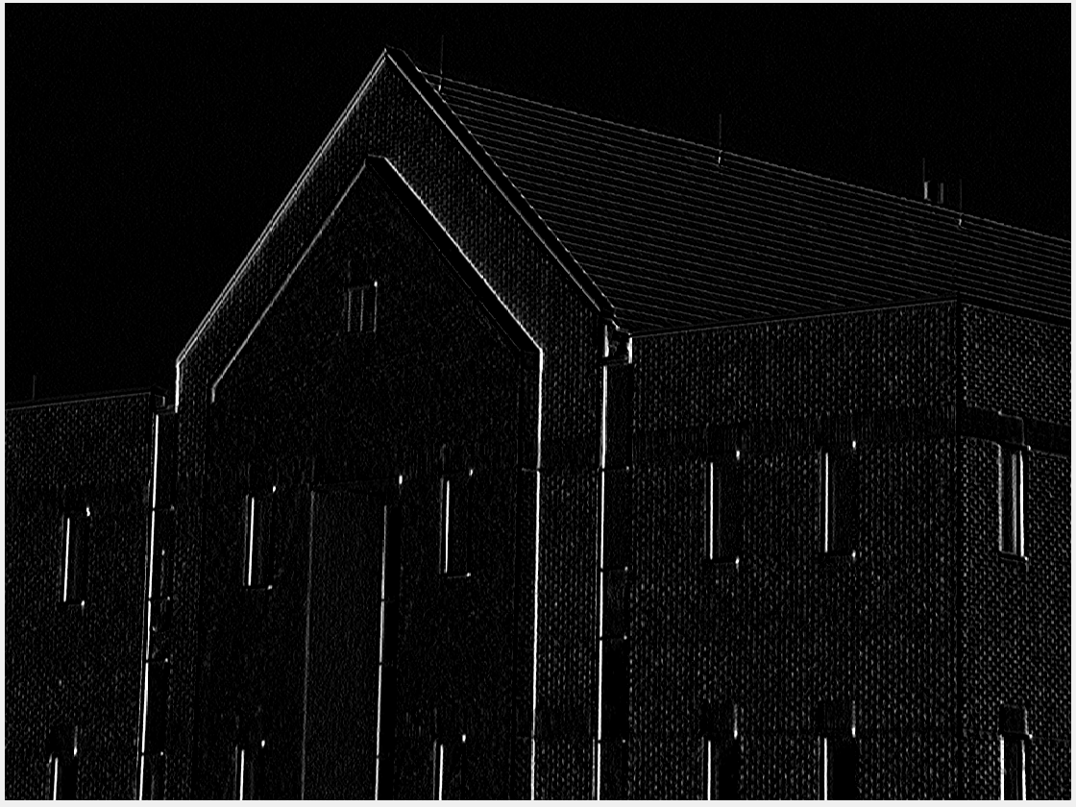

Fig. 1016 Fig. 1016

Gradient Magnitude Gradient Direction

Filter Size 3x3 Filter Size 3x3

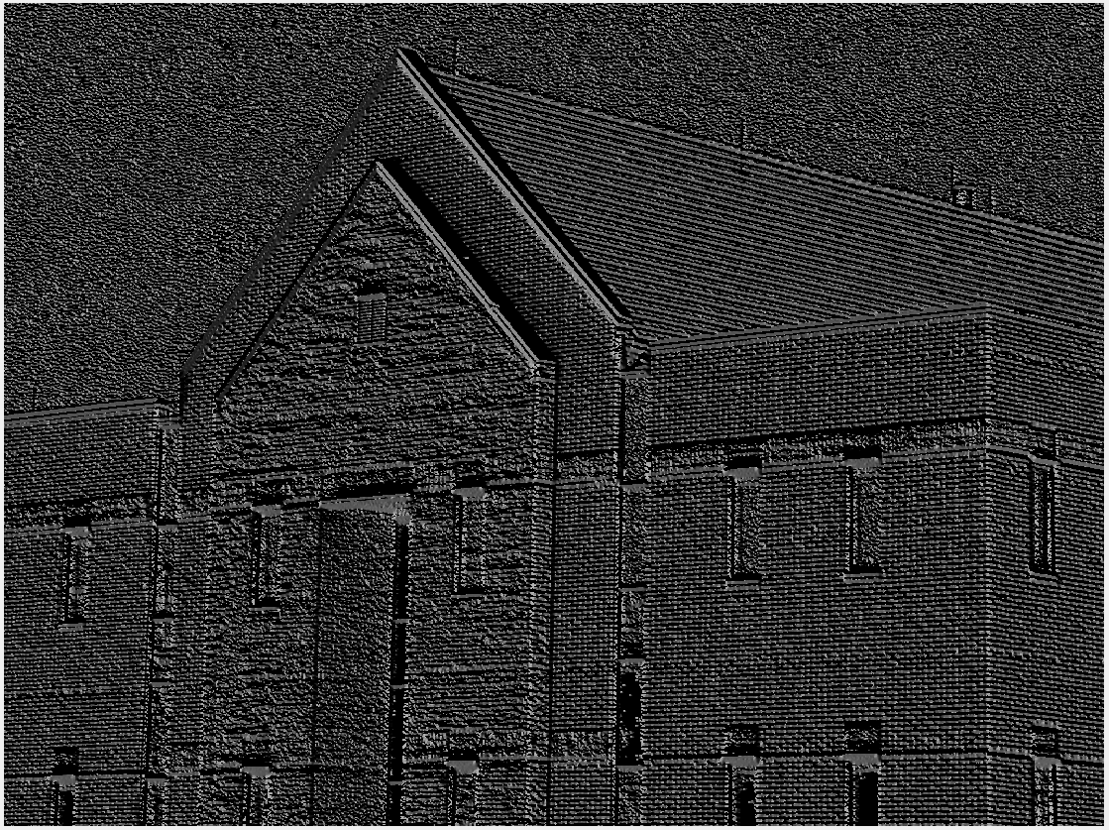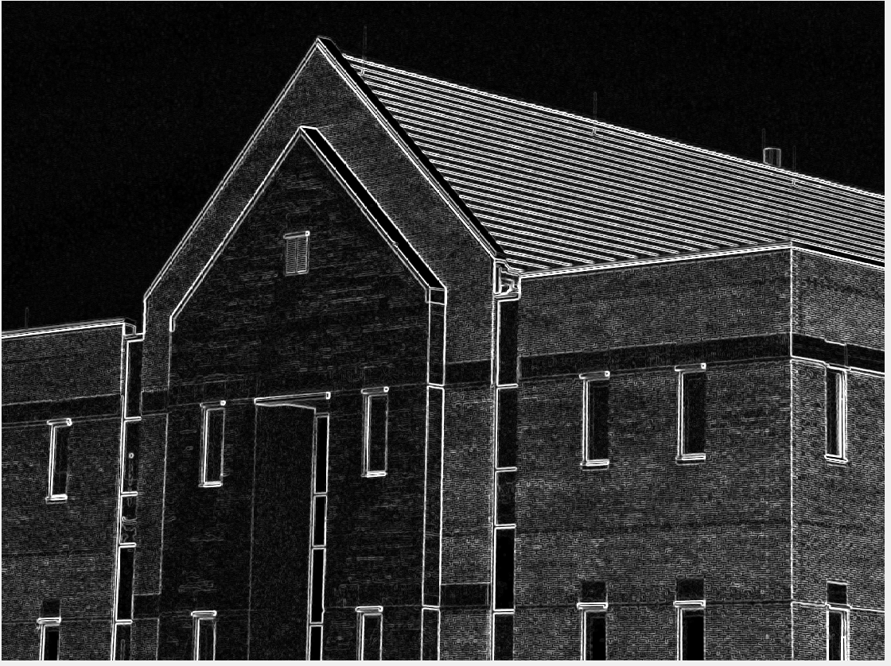

Fig. 1016 Fig.1016

Non-Max Suppression Threshold Low: 50 High: 100

Filter size 3x3 Filter Size 3x3

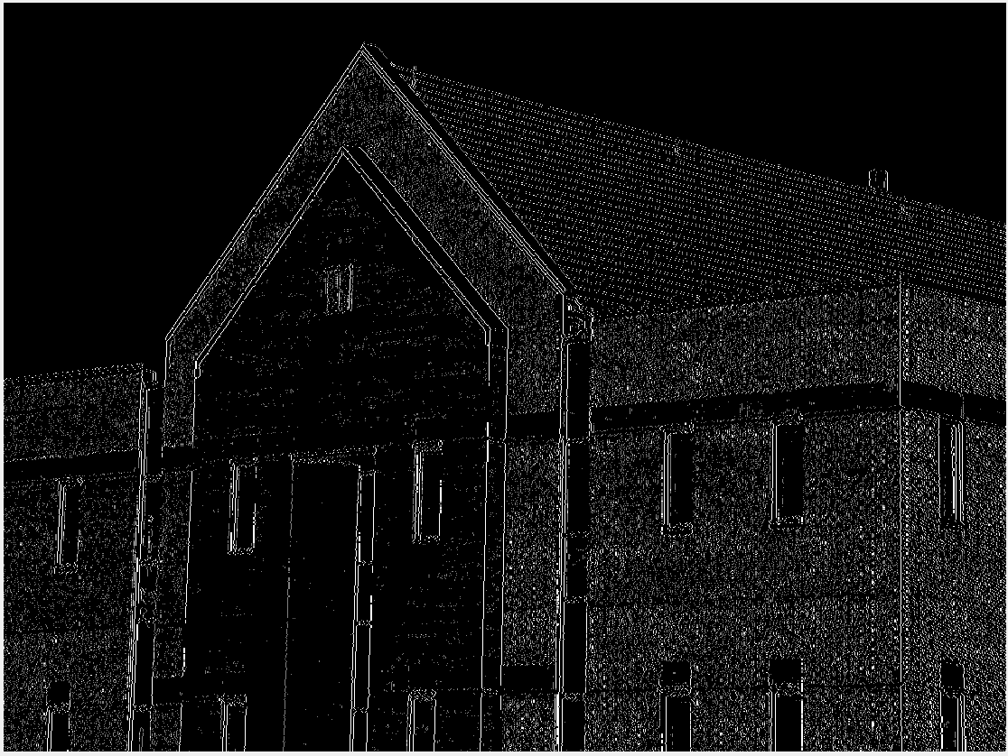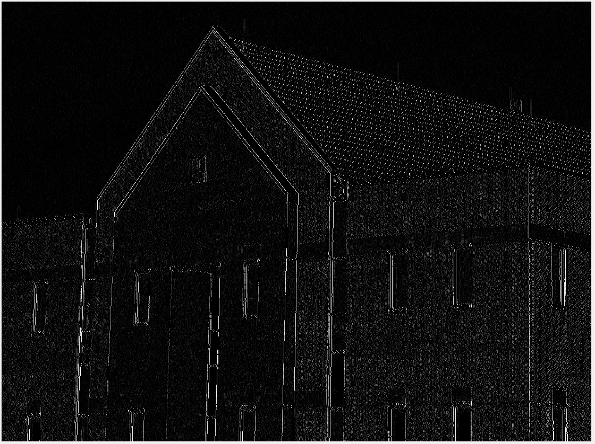

Fig. 1016 Final

Filter Size 3x3

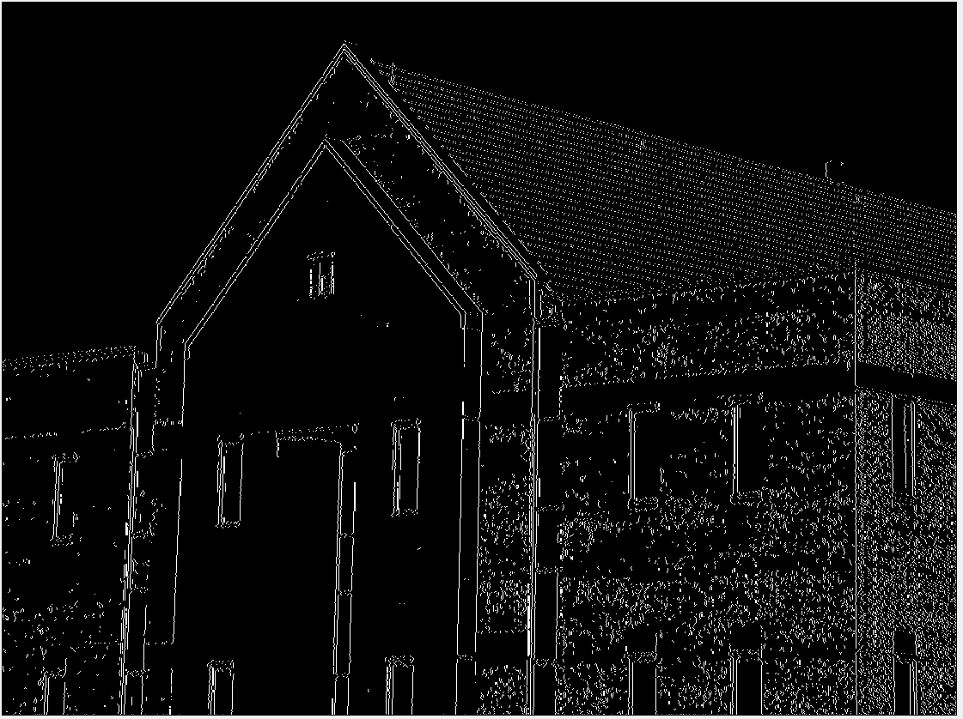

Fig. 1016

Filter Size 11x11

Left: x gradient

Right: y gradient

Lower Left: Gradient Magnitude

Lower Right: Gradient Direction

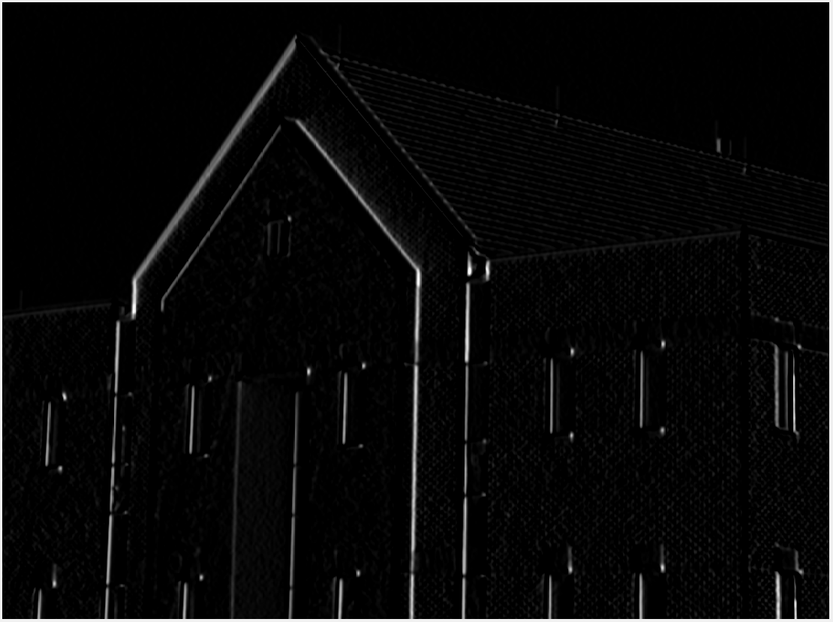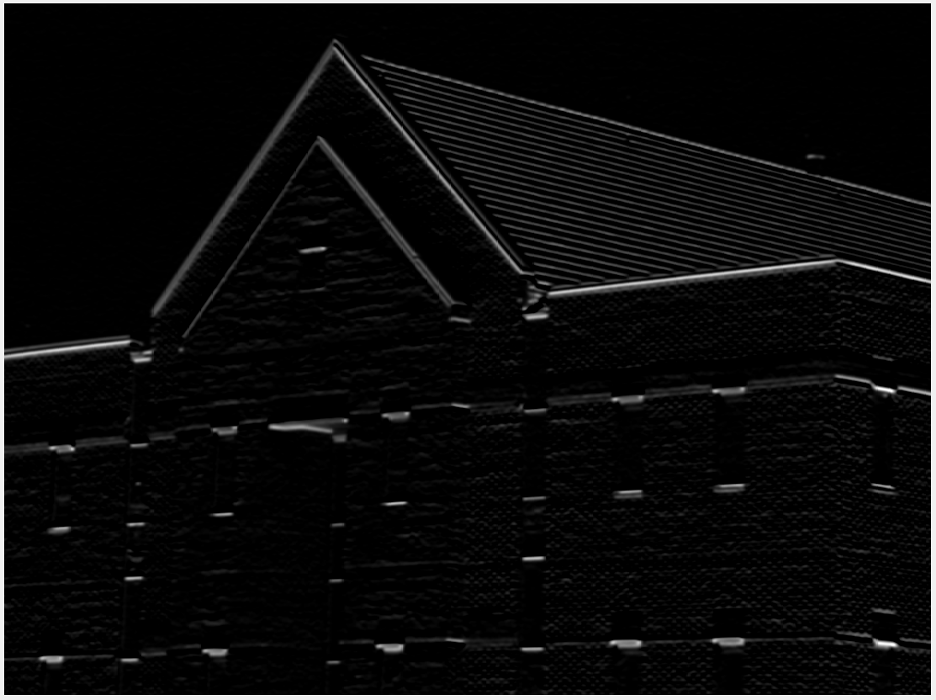

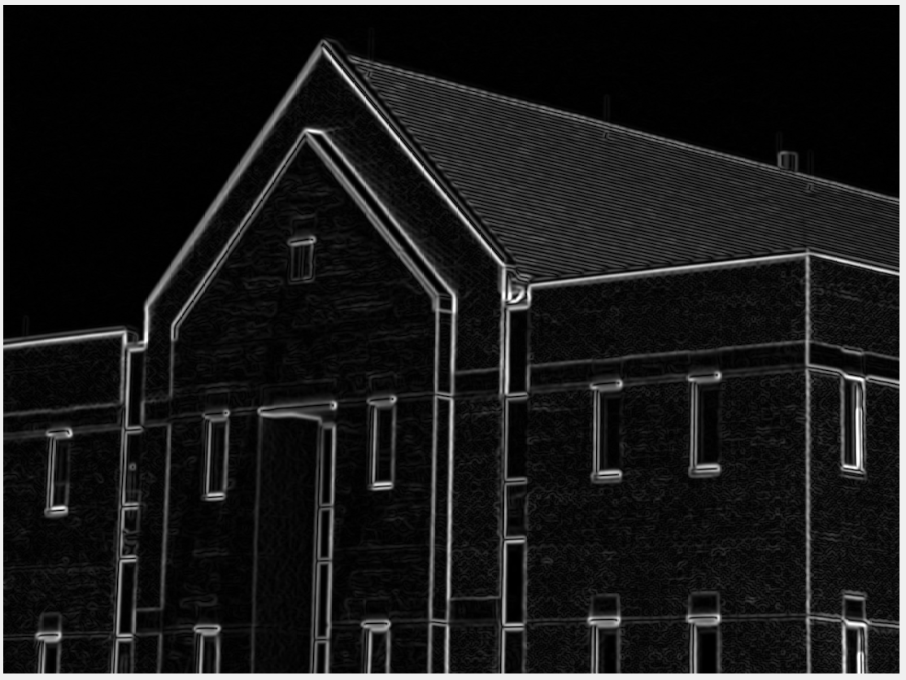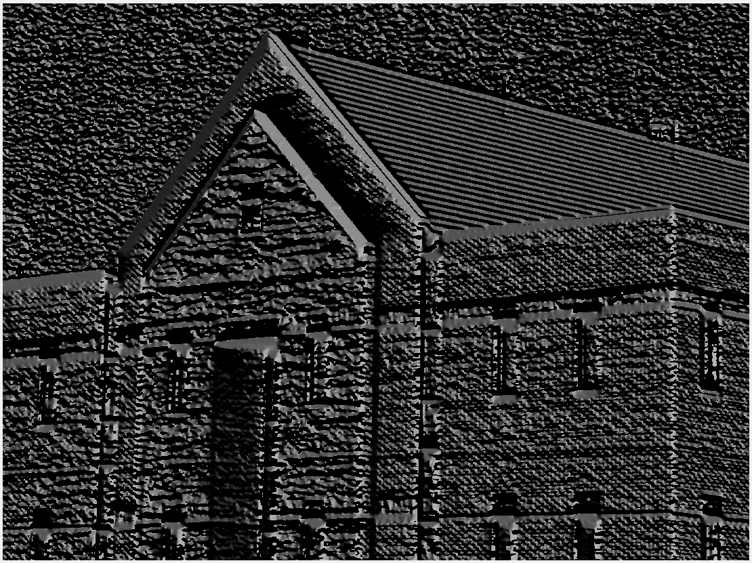

Fig. 1016

Filter Size 11x11

Left: Non-Max Suppression

Right: Threshold High: 100 Low: 50

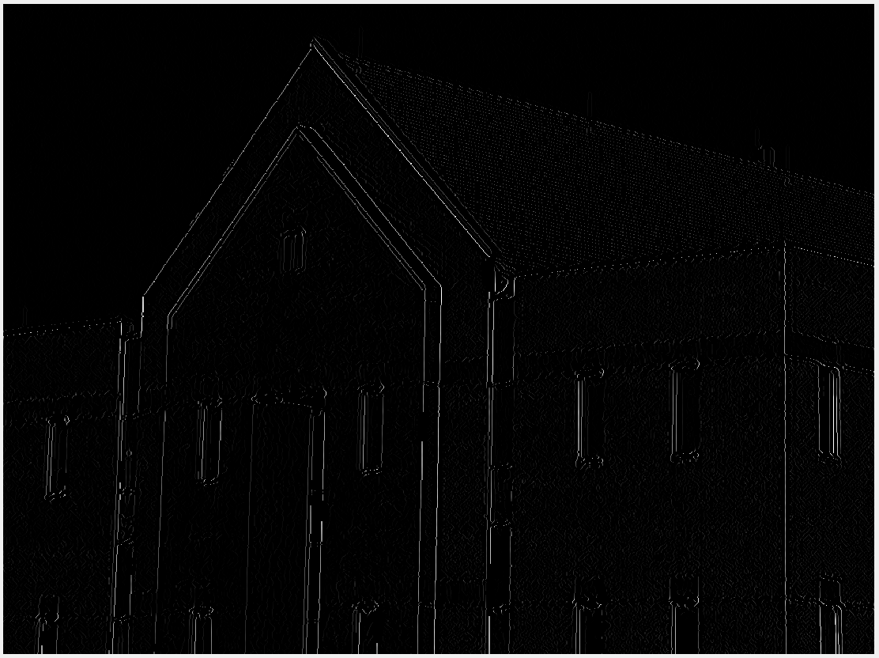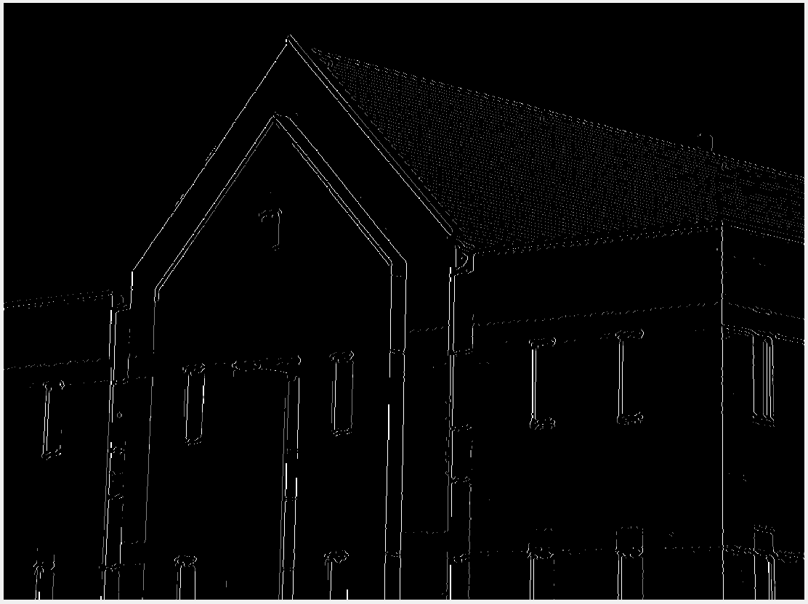

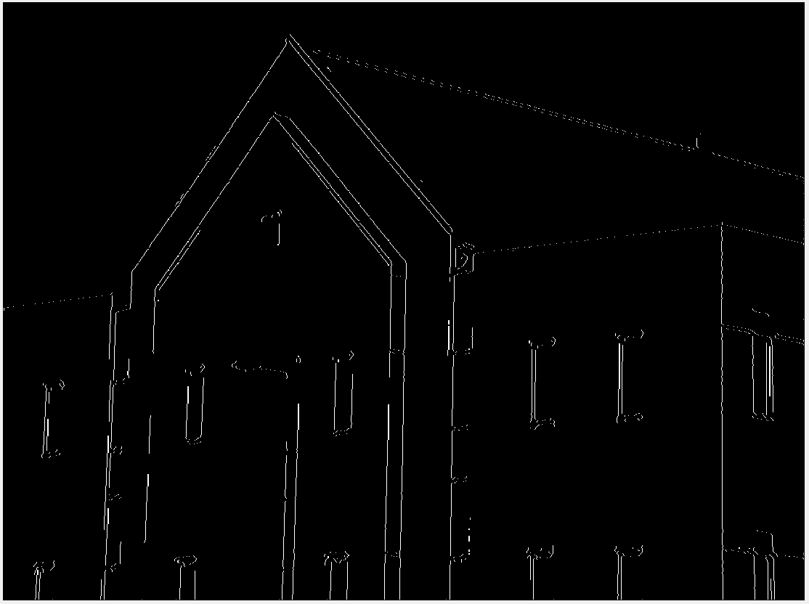Fig. 1016

Final Result

Filter Size 11x11

The 4 images below have the same filter sizes as above. The difference is the Threshold values.

Fig. 1016

Threshold High: 100 Low: 10

Filter Size 11x11

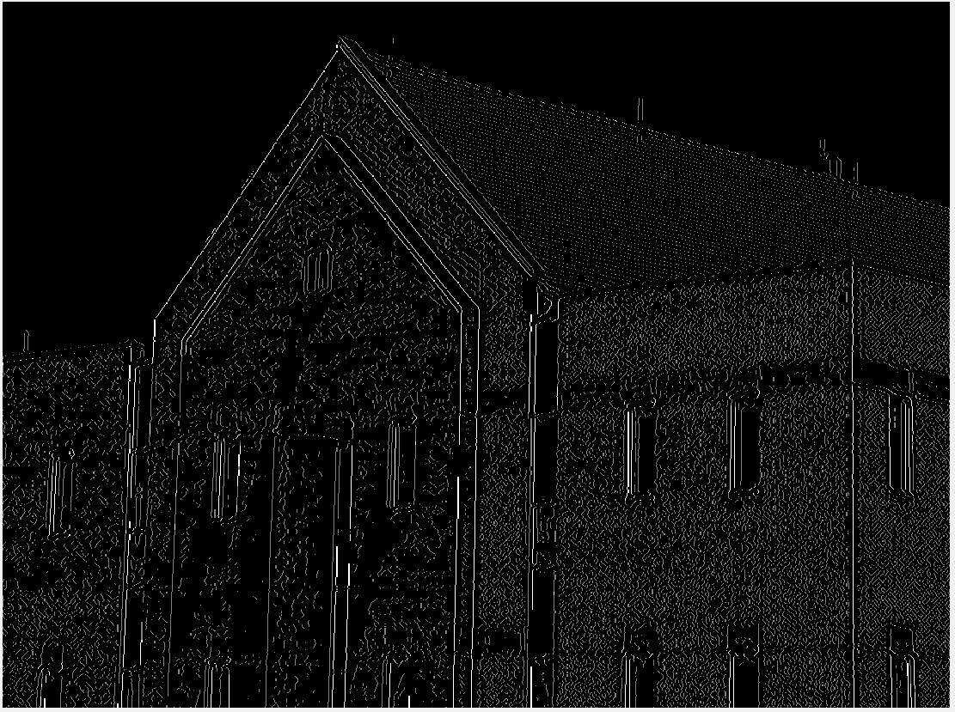

Fig. 1016 Final Result

Threshold High: 100 Low: 10

Filter Size 11x11

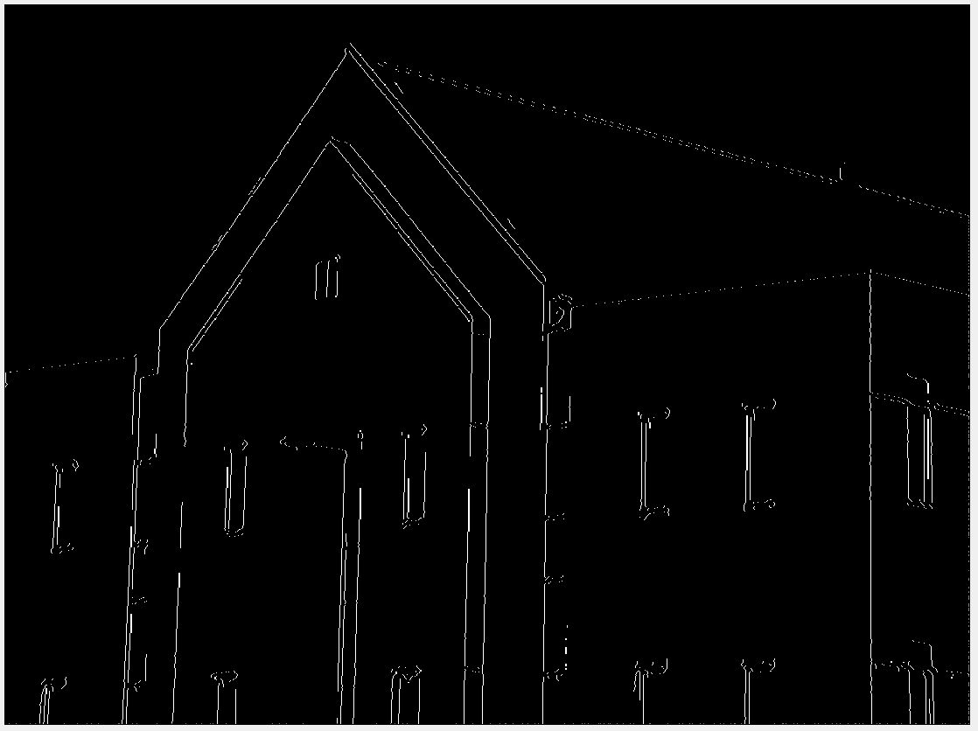

Fig. 1016

Threshold High: 2x Low

Low: median of non-zero pixels

Filter Size 11x11

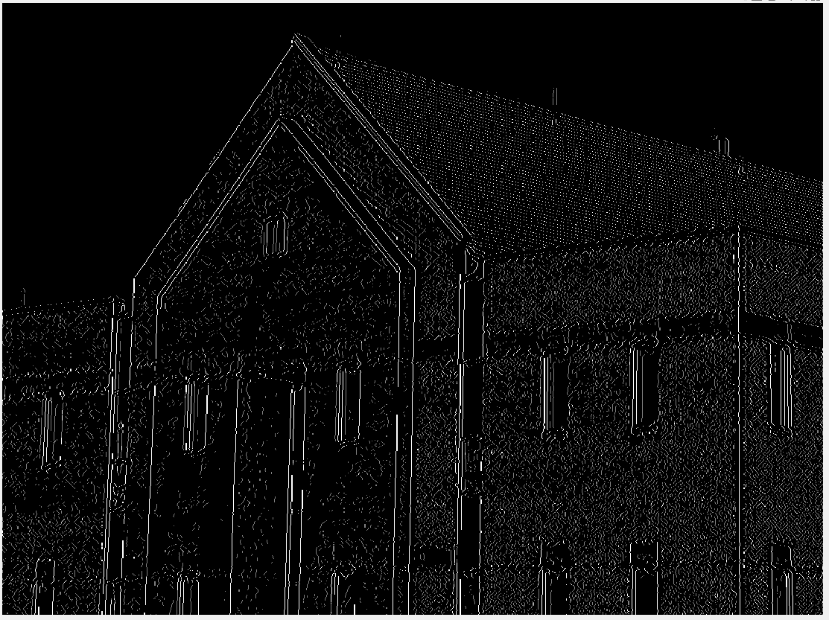

Fig. 1016

Threshold High: 2x Low

Low: median of non-zero pixels

Filter Size 11x11

